**IIoT based 4 axis 4x4 CNC wood router.**



*Group Members:*

|  |  |
| --- | --- |
| **MOATSAM QURESHI** | **(201146)** |
| **MUHAMMAD HANNAN QURESHI** | **(201164)** |
| **MAHAD NADEEM** | **(201182)** |

### BE MECHATRONICS (Session 2020-2024)

**Project Supervisor**

**Sir Umer Farooq Lecturer**

#### DEPARTMENT OF MECHATRONICS & BIOMEDICAL ENGINEERING

#### FACULTY OF ENGINEERING

**AIR UNIVERSITY, ISLAMABAD**

**IIoT based 4 axis 4x4 CNC wood router.**

### FINAL YEAR PROJECT REPORT

### (SESSION 2020-2024)



#### DEPARTMENT OF MECHATRONICS & BIOMEDICAL ENGINEERING

**IIoT based 4 axis 4x4 CNC wood router.**

*Submitted By:*

|  |  |
| --- | --- |
| **MOATSAM QURESHI** | **(201146)** |
| **MUHAMMAD HANNAN QURESHI** | **(201164)** |
| **MAHAD NADEEM** | **(201182)** |



**Engr. Umer Farooq**

**Lecturer**

### Chair Department

**Dr. Noman Naseer**

### Acknowledgments

I would like to express my gratitude towards my supervisors and co supervisor for allowing us to work on this entertaining and enlightening project. We have also to thank the faculty members and the university for this as well.

I would like to express special thanks to our sponsor Tropical Engineering Since 1992, Tropical Engineering Services, a private limited corporation, has operated in Pakistan. The following are the businesses we are involved in Power Plant Supply and Installation, Diesel Gas Generator Sets, Contractual maintenance of air conditioning units and generator sets. producing cutting-edge electrical panels. Production of standard and customized control equipment for the aforementioned industries.

### Abstract

The Computer Numeric Control (CNC) is a technology which tries to bridge the gap between the computers and the mechanical system. It provides an easy and effective way to control the action of a mechanical system by generating, parsing and executing the program instructions and converting them to the electrical signals to control the actuators which are used to control different actions of the machine.

IIoT stands for Industrial Internet of Things. It refers to the network of interconnected devices, sensors, machines, and other equipment that are used in industrial settings such as factories, power plants, and transportation systems. IIoT technologies are designed to enable the collection and exchange of data between these devices, which can then be analyzed and used to optimize processes, reduce downtime, and improve overall efficiency.

A 4-axis CNC machine is a type of computer-controlled machine tool that can machine a workpiece along four different axes. The traditional three axes of X, Y, and Z can be used to move the cutting tool in the directions of depth, verticality, and horizontality.   
By utilizing the fourth axis, often known as the A-axis, the tool can rotate about the X- or Y-axis to access different portions of the workpiece without having to move it.

### Nomenclature

Below are examples of symbols and abbreviations.

*CNC Computerized Numerical Control*

*GRBL Software for G-code operation*

*IIoT Industrial Internet of things*

*16–18-gauge Thickness of iron rods used*

*SDG Sustainable development Goals*

*G-code Code used to operate any CNC*

*WBS Work Breakdown Structure*

*DS Data Software*

*STCP Storage Resistor Clock*

*SHCP shift Register Clock*

*PCB Printed Circuit Board*

*Q0-Q7 Control Parameter*

*DMA Direct Memory Access*

### Table of Contents

Table of Contents

BE MECHATRONICS (Session 2020-2024) 1

FINAL YEAR PROJECT REPORT ii

(SESSION 2020-2024) ii

Chair Department iii

Acknowledgments iv

Abstract v

Nomenclature vi

Table of Contents vii

List of Figures ix

List of Table xi

1 Introduction 1

CNC: 1

4 axis CNC: 1

Router: 1

IIoT (Industrial Internet of Things): 2

1.1. Background and Motivation 2

1.2 Problem Statement 3

1.3 Objectives of the Project 3

1.4 Scope of the Project 4

1.5 Cost Analysis 4

1.6 Timeline of the Project 5

1.7 Work Division 5

1.8 Comparison of the product 6

2 Description 9

2.1 Description of the Project 9

2.2 Literature Review 9

2.3 Methodology 11

2.4 Product Specifications 12

2.4 Preliminary Design and Calculations 14

3 Modelling and Simulation 17

3.1 Product parameters 17

3.2 CAD Modelling 17

3.3 3D Model Analysis 18

3.4 Algorithm 19

4 Experimental Setup 22

4.1 Hardware Description 22

4.2 Components: 22

5 Results and Discussion 37

5.1 Results 37

5.2 Discussion 37

5.3 Project Outcome 38

6 Conclusions and Future Recommendations 39

6.1 Conclusions 39

6.2 Future Recommendations 39

Bibliography 40

Appendix 42

Turn it in Report 44

### List of Figures

Figure 1 CNC machine 1

Figure 2 Block Diagram 3

Figure 3 Gantt chart 5

Figure 4 WBS 6

Figure 5 Axiom Precision AR4 Pro+ 6

Figure 6 Laguna Tools IQ 7

Figure 7 CNC pirnha FX 7

Figure 8 schematic design 14

Figure 9 BED drawing 14

Figure 10 y axis mountings 15

Figure 11 Frame diagram 16

Figure 12 3D model 17

Figure 13 Stress 18

Figure 14 Displacement 18

Figure 15 Factor of safety 19

Figure 16 Flow chart 21

Figure 17 Ball screw 22

Figure 18 Driver 23

Figure 19 Motors 24

Figure 20 Sensor 25

Figure 21 Frame 26

Figure 22 Y axis 26

Figure 23 Rack 27

Figure 24 Slide and bearings 28

Figure 25 Wire duct 28

Figure 26 PCB 29

Figure 27 chuck 29

Figure 28 Esp 32 30

Figure 29 Tail Stock 30

Figure 30 LCD 31

Figure 31 Capacitors 31

Figure 32 IC 32

Figure 33 stoppers 33

Figure 34 Gear mount 33

Figure 35 Belt 34

Figure 36 Gear box (pinion) 35

Figure 37 Resistors 36

### List of Table

Table 1 Cost analysis of material required. 4

Table 2 Proposed device comparison with others 8

Table 3 List of Expenditures 38

# 1 Introduction

### CNC:

[1]Computerized Numerical Control is referred to as CNC. It is a computerized manufacturing process in which production equipment is moved under the control of pre-programmed software and code.

The automated use of a computer to control machining equipment is known as numerical control. According to coded programming instructions and without a manual operator directly managing the machining operation, a CNC machine processes a piece of material to fulfil standards, as shown in *figure 1*

### axis CNC:

[2]A computer-controlled machine tool that can conduct machining operations on a workpiece along four separate axes is known as a 4-axis CNC machine. The cutting tool can move in the horizontal, vertical, and depth directions using the standard three axes of X, Y, and Z.

The tool may access various sections of the workpiece without having to move it by rotating it about the X-axis or Y-axis using the fourth axis, which is commonly referred to as the A-axis.

### Router:

[3]To hollow down a piece of wood, metal, or plastic, use a router. It can create patterns, decorative edges, or grooves. A fixed base and a plunging base are the two different categories of routers. An example of a CNC machine is shown in *Figure 1.*

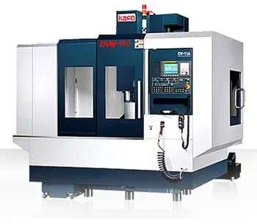

Figure CNC machine

### IIoT (Industrial Internet of Things):

[4]IIoT stands for Industrial Internet of Things. It refers to the network of interconnected devices, sensors, machines, and other equipment that are used in industrial settings such as factories, power plants, and transportation systems. IIoT technologies are designed to enable the collection and exchange of data between these devices, which can then be analyzed and used to optimize processes, reduce downtime, and improve overall efficiency.

IIoT technologies can include sensors and other hardware devices, as well as software platforms and applications that are used to manage and analyze data. Some common examples of IIoT applications include predictive maintenance systems, supply chain management tools, and real-time monitoring and control systems.

IIoT is seen as a key driver of the Fourth Industrial Revolution, as it has the potential to transform the way that industrial systems are designed, operated, and maintained.

### Background and Motivation

##### Sustainable Development Goals

[5]Goal 9: Industry, Innovation and Infrastructure:

According to the UN, infrastructure investments are essential to ensuring sustainable development and empowering communities in many nations. This includes investments in transportation, irrigation, electricity, and information and communication technologies. Infrastructure investment is known to be necessary for productivity and income growth, as well as for gains in health and educational results.

This machine is not only cost effective and easier to run, it also allows an IoT based control system which would innovate the current way of CNC usage and construction as it is in the country.

The local machinery and the ones that are present are mostly too complicated for the masses, for this purpose we have decided to construct a 4 axis CNC which can be controlled remotely and by everyone else with even a shred of knowledge regarding it. The device being designed by us is short in terms of power compared to others but the availability and complexity of the product usage is at an amateurish level and crystal clear for the user and cheap to use for the client.

### Problem Statement

[6]In the modern world, with the introduction of Industry 4.0, the Automation, Smart Machines & Factories, plays an important role in the manufacturing industry, but there is Lack of availability of IoT based 4-Axis CNC routers. The diagram which represents the working diagram and methods is given below in *figure* 2. Such CNCs that could be operated through wireless medium, and their use does not require advanced knowledge of the operation of CNC machines. CNC machines have a 4th Axis allowing them to turn over the sides of the workpiece without the need of external intervention.

### 1.3 Objectives of the Project

Figure Block Diagram

Main objectives for this project are as follow:

* + - Design a low budget Product for the local market.
    - Implement the use of IIoT.
    - Make the machine user friendly and easy to use

### Scope of the Project

The scope of this project refers to our limitations and criteria:

* The average price of a CNC wood router in Pakistan is 1 million to 1.2 million, so the intention is to bring have the price down to Rs 200000 to Rs 300000 foir the design.
* The size of the router workspace is 4x4 ft.
* It is designed for of predictive maintenance and cloud synchronization.

### Cost Analysis

The average price of a CNC wood router in Pakistan is a million rupees, and the price for construction is even higher.

|  |  |
| --- | --- |
| **Materials** | **Unit Prices** |
| Aluminium T Slot | Rs.12500 |
| Z axis (lead screw) | Rs. 10000 |
| Motor driver | Rs. 4500 |
| Stepper Motor | Rs.10000 |
| MCU (ESP 32) | Rs.1200 |
| LCD display | Rs.6000 |
| Limit Switch | Rs.30 |
| Rack and pinion | Rs.12000 |
| Wires | 2000 |
| Z axis | 20000 |
| Total | 78000 |

Table Cost analysis of material required.

### Timeline of the Project

The timeline of the project as of now is shown in *figure 3*:

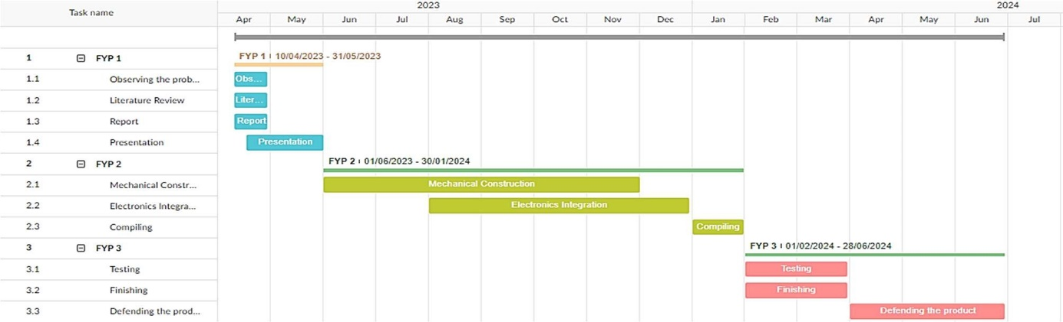

Figure Gantt chart

* The first part of the project (FYP-I) which would deal with the literature review, the reporting and presentation regarding the project and would be concluded till the end of semester 6.
* The second part of the project (FYP-II) which is dedicated to the construction and modelling of the CNC machine till the end of the 7th semester.
* The FYP-II will also be undertaken throughout the summer event of the final year.
* The last semester and FYP-III will be the testing phase of the project and would include the defense and consistency of our project.

It has been concluded that this timeline is drafted ideas and discussions with the group members and the project supervisor. This timeline might be exposed to minor or major changes throughout the life of the project.

### Work Division

Currently the work is purely theoretical the WBS diagram representing task allocation of assets to the group members is shown in *figure no 4*:

* Mahad Nadeem would be the person working on the electronic aspect of the machine.
* Moatsam Qureshi would be responsible for the Mechanical aspects of the project.
* Muhammad Hannan Qureshi would be responsible for designing, reporting and assisting the fellow group members

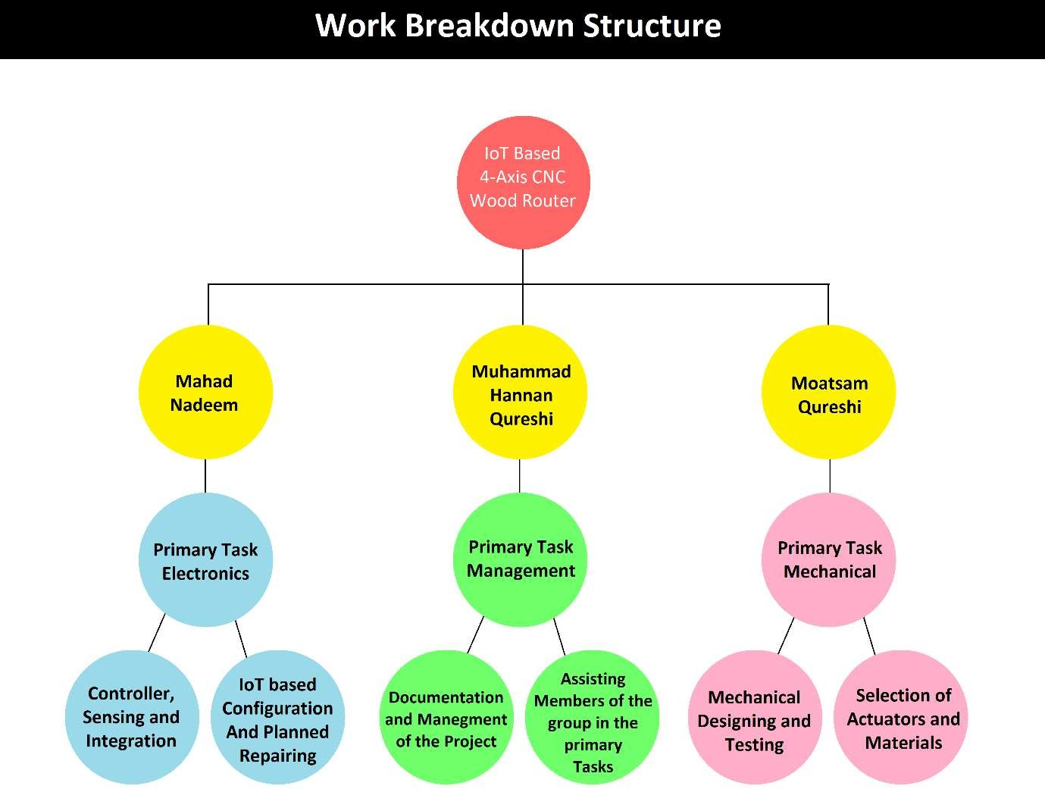

Figure WBS

### 1.8 Comparison of the product

#### Axiom Precision AR4 Pro+

The Axiom Precision AR4 Pro+ is a high-precision CNC router designed for professional woodworkers and small business owners. It features a large working area of 24" x 24" and is capable of cutting through a variety of materials including wood, plastics, and non-ferrous metals. The machine is equipped with a powerful 3HP liquid-cooled spindle motor that can rotate at speeds of up to 24,000 RPM,

Figure Axiom Precision AR4 Pro+

providing fast and accurate cutting performance. The AR4 Pro+ also features a steel frame construction that provides stability and reduces vibration during cutting operations, ensuring high-quality and precise cuts. The AR4 Pro+ is a reliable and efficient CNC router that is ideal for small businesses, woodworking shops, and professional woodworkers who require high-

precision cutting and routing capabilities. As shown in *figure no 5.*

#### Laguna Tools IQ

The Laguna Tools IQ is a compact and versatile CNC router designed for hobbyists and small 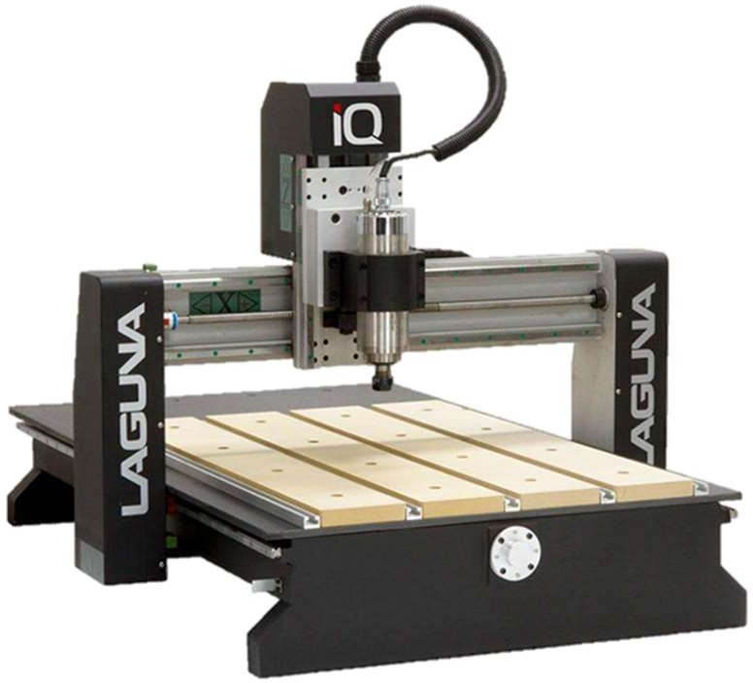business owners. It features a working area of 24" x 36" and is capable of cutting through a variety of materials including wood, plastics, and non-ferrous metals. The machine is equipped with a 3HP liquid- cooled spindle motor that can rotate at speeds of up to 24,000 RPM, providing fast and accurate cutting performance. The IQ also features a sturdy steel frame construction that provides stability and reduces vibration during cutting operations, ensuring high-quality and precise cuts. The IQ is a reliable and efficient CNC router that is ideal for small businesses, woodworking shops, and hobbyists who require high-precision cutting and routing capabilities in a compact package. As shown in *figure no 6*

Figure Laguna Tools IQ

#### [7]CNC Piranha FX

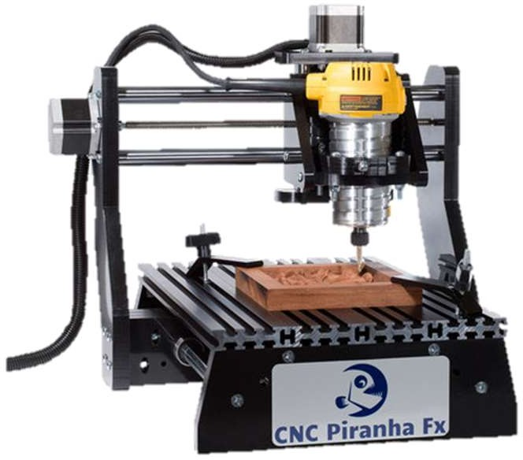The Laguna Tools IQ is a compact and versatile CNC router designed for hobbyists and small business owners. It features a working area of 24" x 36" and is capable of cutting through a variety of materials including wood, plastics, and non-ferrous metals. The machine is equipped with a 3HP liquid-cooled spindle motor that can rotate at speeds of up to 24,000 RPM, providing fast and accurate cutting performance. The IQ also features a sturdy steel frame construction that provides stability and reduces vibration during cutting operations, ensuring high-quality and precise cuts. The IQ is a reliable and efficient CNC router that is ideal for small businesses, woodworking shops, and hobbyists who require high-precision cutting and routing capabilities in a compact package. As shown in *figure no 7.*

Figure CNC pirnha FX

|  |  |
| --- | --- |
| **Local available Machines** | **M3 CNC router** |
| Requires a person on spot to control the machine | Is IIoT based and can be controlled remotely |
| Does not allow rotation of the workpiece. | Allows rotation of the workpiece using the 4th axis. |
| Requires to manually turn over the sides of the workpiece | Can rotate or turn over the workpiece by itself |
| Can make Drill holes only at one Angle. | Can make Drill holes at different angles with respect to each other. |
| Require moderate or high-level skill to operate. | Does not require any high-level skill to operate. |
| Only usable in moderate or large- scale industries. | The machine is feasible for small scale industrial units. |
| Have fixed or manually changeable work tools. | Have an automated tool changer embedded with the microcontroller. |

Table Proposed device comparison with others.

# 2 Description

In the previous segment, a literature review of topics regarding the project was performed, furthermore an observation at similar products in the market currently available and identified the approach for this particular topic.

### Description of the Project

The decision is to design and create a 4 axis CNC wood router which would be able to perform tasks remotely using concepts of IoT. It will be built using an iron frame and will use stepper motors for movement across all four axes i.e. X, Y, Z and A.

The project would be able to decrease the time taken by a plant to work on a workpiece because using IoT we can make it so the machines in vicinity of each other can work in unison which will save time and work force efforts. This will also help the industry by decreasing the safety hazards in a working area.

### Literature Review

* + 1. [8]Index 4-axis CNC machining occurs when the work piece is rotated by the machine's fourth axis (A-axis), but no material is being cut. Once the proper rotation has been chosen, the machine resumes cutting once a brake is applied. Continuous 4-axis CNC machining occurs when the machine can simultaneously spin the A-axis and cut the material. The development of affordable CNC machine tools has kept pace with that of science and technology. It is extensively utilized by small and medium-sized businesses because of the benefits of low cost and open source. However, when processing high precision workpieces, there are drawbacks of insufficient interpolation.

As a result, the goal of this project is to create a four-axis CNC system based on the differential interpolation concept that takes into account both PC and Arduino features. determines the upper and lower machine control scheme of “PC + Arduino MCU” and builds a four-axis CNC engraving machine experimental platform. On this platform, interpolation of the conic curve and rotary surface is completed.

The four-axis CNC system design meets the initial design requirements and lays a good

foundation for the development of high-end multi-axis CNC systems.

* + 1. [9]Paulo Augusto Sheering da Rocha Junior et al. studied a design of CNC

prototype machine with three cartesian axes with 600mm of length both X and Y axis and 100 mm of length Z axis. Three stepper motors with holding torque of 10 kgf-cm, 8W of power per phase, 1.8° step angle and positioning precision higher than 95% were used to control the motion of the spindle in X, Y and Z axis.

As an end effector, a universal DC machine with nominal speed of 35000 rpm was used. The software to control and load the program into the machine was designed in the LabVIEW integrated development environment (IDE). The transfer of instructions from the software to the machine was by using Universal Serial Bus (USB) based on a PIC18F2550 microcontroller.

* + 1. The five-axis machining process may be modelled and simulated, which can be utilized to choose the right process parameters and improve both productivity and quality. The G-code command programmes, a standard for the CNC machines industry, is used to programmes the CNC machines to generate the necessary tool trajectory. For straightforward parts, a manual G-code programmes can be written. CAM software commonly generates G-code programmes in two steps, directly from CAD models. A list of the tool positions in the coordinate system of the workpiece, known as the generic cutter locations data (CLDATA), is used to produce the tool routes first. The post-processor unique to CNC machines must then transform these cutter locations into G-code programmes. There is a wide variety of CAM software that is compatible with CNC five-axis machines, but because of how differently these systems' functionalities are made available, it is crucial to pick the right one. Advanced CAM programmes can do inclined millings, in which the tool is angled away from the surface normal and the tooltip is brought into contact with the material. A process for deriving milling conditions from cutter location data and a workable technique for integrating the model of a five-axis CNC machine with the CAD/CAM systems are established in the study. The simulation of the milling forces in a cycle and the scheduling of the feed rate to reduce cycle duration serve as examples of how this approach is used.
    2. [10]The smallest CNC machine that can perform the same tasks as larger CNC machines is known as a little CNC machine. The sole distinction is that this machine can perform the operation regardless of the part's size. Turning machines and milling machines are the two categories under which this machine often falls. Modular Computer Numerical Control (CNC) Machine Manipulator Design and Development for Automation Muhamad Safwan Hilmi, Pranesh Krishnan, and Johan Ihsan Mahmood Design and Development of a Modular A tiny CNC machine is created using only these two procedures. In a turning machine, the tool is moved back and forth and in and out until the desired shape is obtained. The workpiece rotates at a high speed. For a milling machine, a tool that rotates and cuts in multiple directions and moves in three separate directions along the axis is a part of the machine. It should be compact and lightweight since it will be used as a research or instruction package. There must be enough movement on the worktable. There can be just one degree of freedom for the spindle head. The Z-drive must be reduced in order to increase torque.

### Methodology

#### Project overview:

The goal of this mechatronics project is to develop a 4 axis CNC wood router which will provide ease of access to the users and will be helpful in branching the industry towards more advanced ways of manufacturing.

#### Research design and approach:

The project follows a design-build-test approach, where to design the mechanical and electronic components, then fabricate them, program the embedded systems, develop the control software, and finally test the complete system.

#### Hardware Fabrication:

The modelling of the project using CAD software which will consist of following parts:

* 1. A frame made from iron.
  2. We can manufacture the mountings of y axis using Iron sheet.
  3. Rack and pinion.
  4. Aluminium rails and slides.

#### Embedded system development:

Following items for our machine for the control aspect will be used:

* 1. An esp 32 as the microcontroller
  2. A software named Aspire converts our drawings and sketches into G-codes.
  3. An open-source firmware named Fluid NC will be utilized which will feed the G-code to the microcontroller.

#### Testing:

Testing has been conducted thoroughly of both softwares and purchased hardware in a workshop within the duration of summer. Both softwares were used to run a pre-built machine and its conversion of sketches into G-codes and feeding the said codes into the machine. The y axis was disassembled and reassembled before mounting the motor on the shaft which was tested thoroughly as well.

#### Ethical consideration:

To ensure the safety of participants and bystanders during testing, clear boundaries have been maintained and provided safety instructions to anyone present in the testing area.

### Product Specifications

The product being developed will contain features and specifications as listed below:

* A 4th axis which will allow rotation of the workpiece without interruptions.
* With the use of IoT we can allow machines to operate remotely.
* The product will be able to work in a CNC farm to increase productivity.
* The product will be able to provide a safer work environment.
* The product contains the ability to lower the overall expenditures of any industrial sector.

***2.3.1 Schematic Diagram***

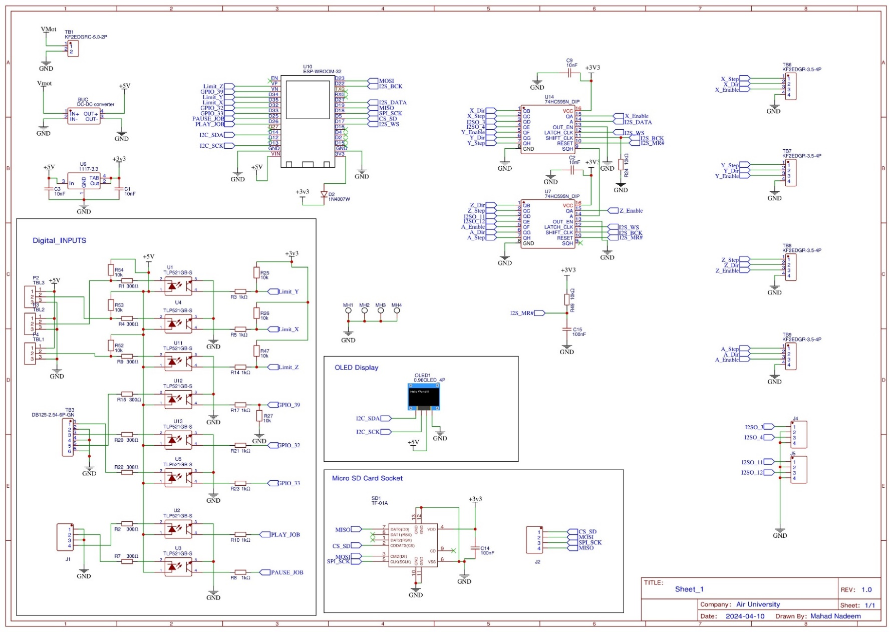

Figure schematic design

### 2.4 Preliminary Design and Calculations

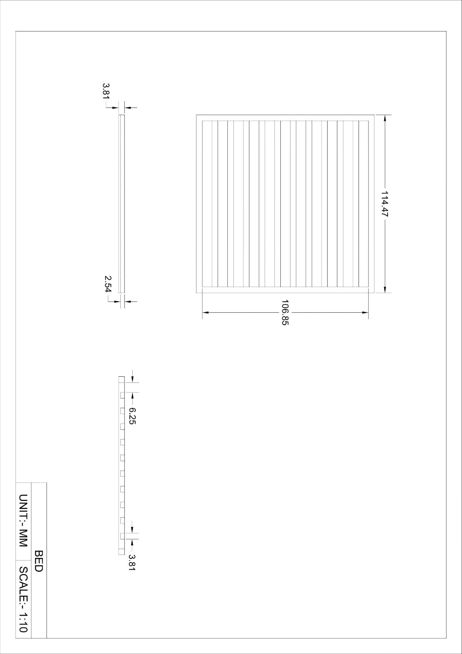

Figure BED drawing

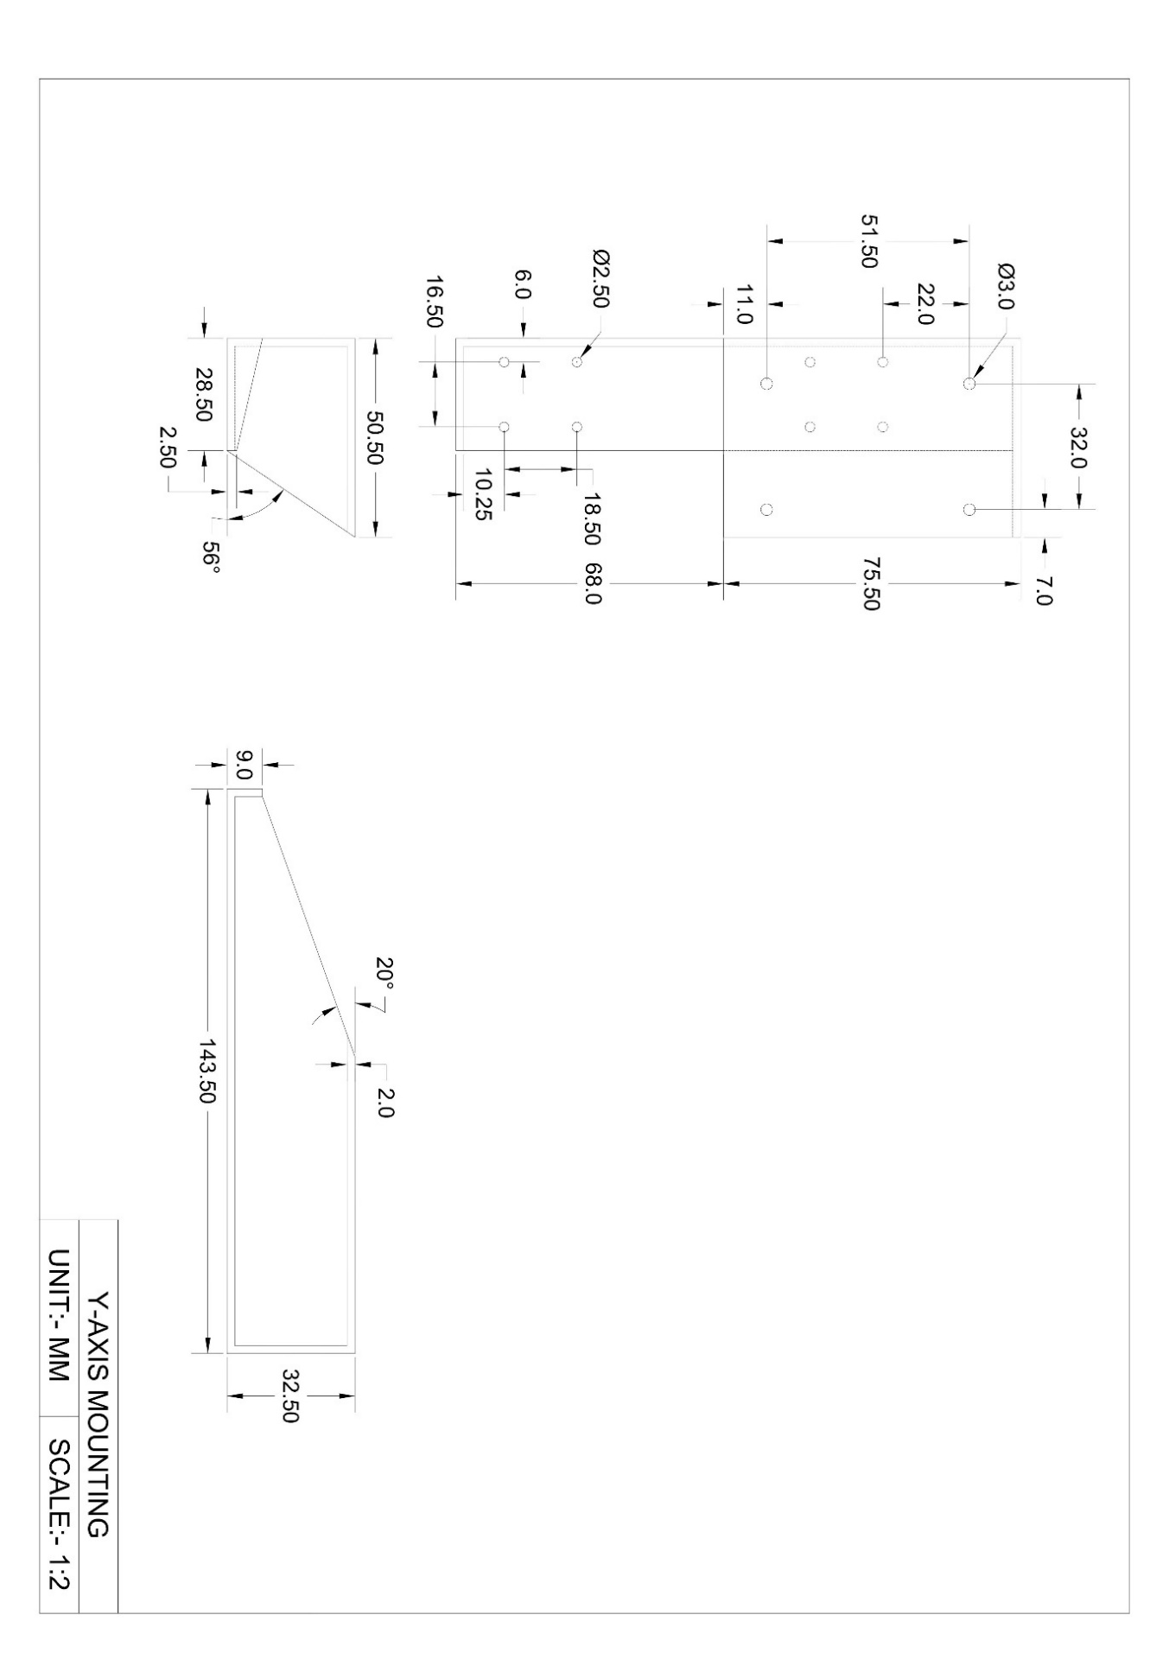

Figure y axis mountings

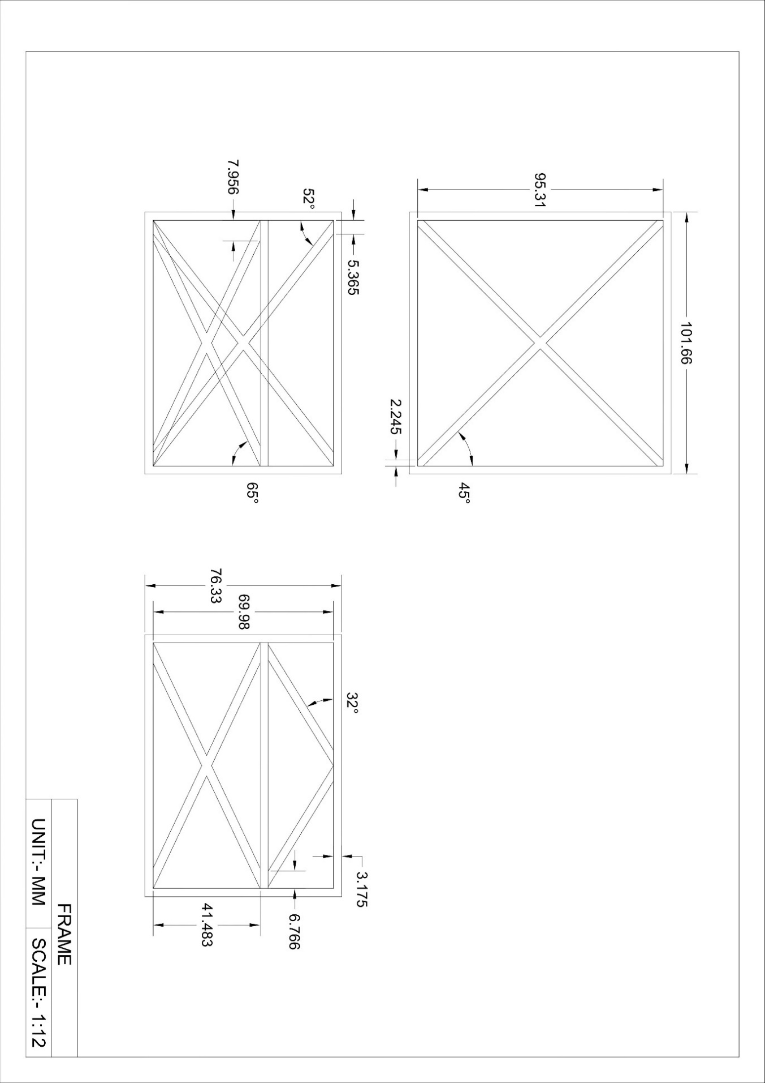

Figure Frame diagram

# 3 Modelling and Simulation

In this chapter modelling and simulations will be performed for the production of the CNC. Largely apply SolidWorks software for designing and simulating the results of the product under stress. Furthermore, the use of open-source firmware such as Fluid NC to run the device with designated input.

### 3.1 Product parameters

Machine Height = 1417 mm

Machine Length = 1574 mm

Machine Width = 1727 mm

Workpiece max length = 862 mm

Workpiece max diameter = 1219 mm

Materials used = Iron rods and sheets

Actuators used = Rack and pinion.

Microcontroller used = ESP 32

Motor Used = Nema 32 Stepper Motor

### 3.2 CAD Modelling

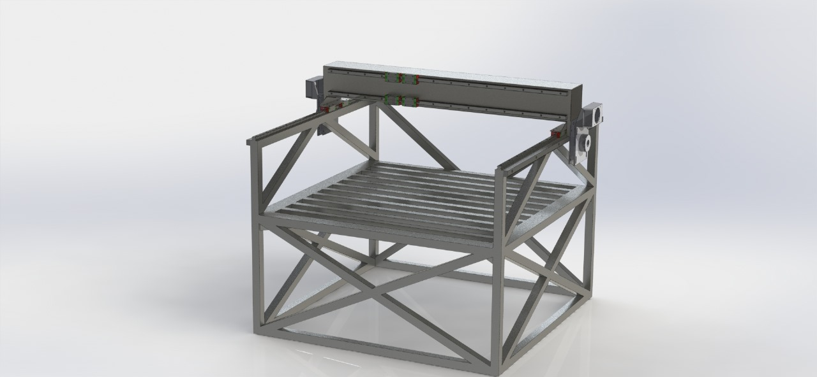

Figure 3D model

### 3.3 3D Model Analysis

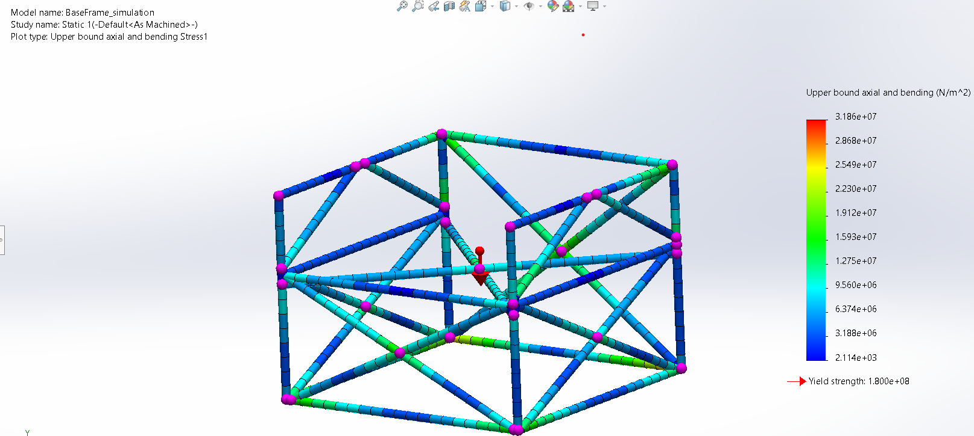

Figure Stress

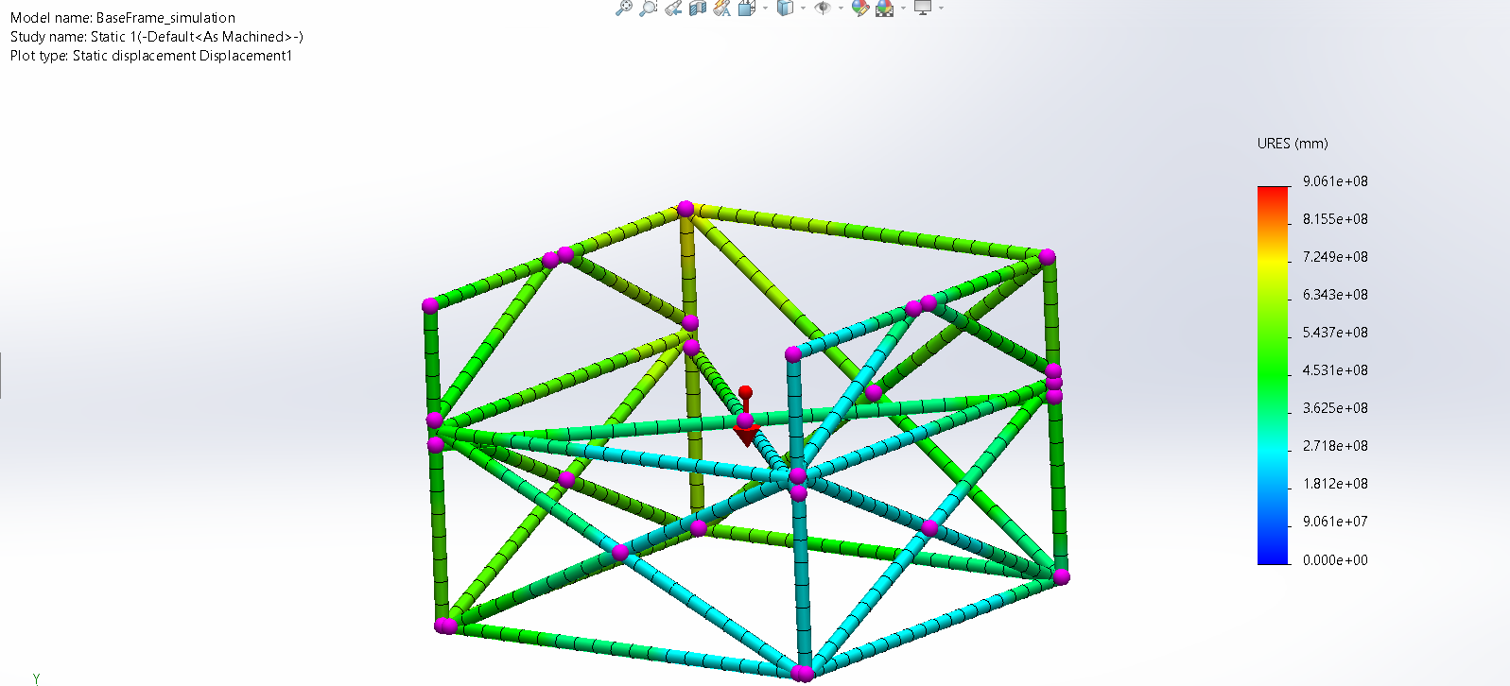

Figure Displacement

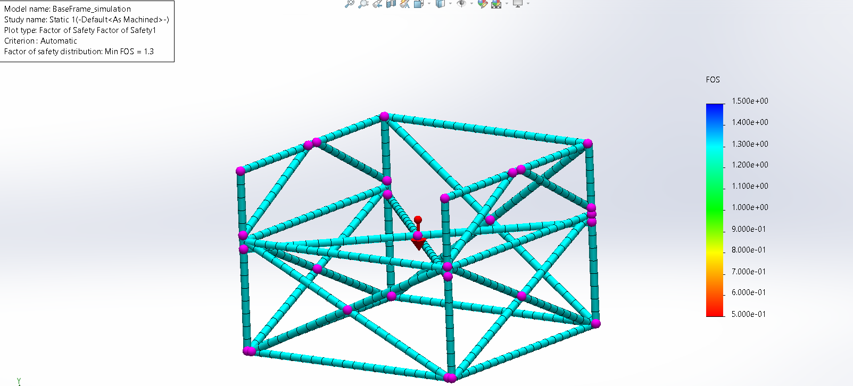

Figure Factor of safety

### 3.4 Algorithm

[11]The controller being used is an ESP-32 in our project because of its low cost, low power consumption, and built-in Wi-Fi and Bluetooth capabilities. It’s a versatile microcontroller commonly used in IoT (Internet of Things).

[12]FluidNC is an open-source CNC (Computer Numerical Control) firmware specifically designed for the ESP32 microcontroller. It uses the same Motor movement algorithm as Grbl CNC firmware. Grbl CNC firmware is the software that controls the movement of motors and tools in computer-controlled machining systems, such as milling machines, lathes, or 3D printers. Grbl was originally developed for AVR microcontrollers. While FluidNC is specifically designed for the ESP32 microcontroller.

FluidNC leverages the capabilities of the ESP32 hardware, such as its processing power and connectivity options, to provide additional CNC control functionality. This firmware offers features such as G-code interpretation, motor control, homing from Grbl and Additional networking capabilities for remote control or monitoring of CNC machines.

The Firmware have a browser-based Web UI (ESP3D-WebUI) so you control the machine from a PC, phone, or tablet on the same Wifi network. WebUI is a separate open-source project for computer-controlled machining systems, such as milling machines, lathes, or 3D printers. And can be incorporated into Fluid NC.

It is compulsory for the controller to be connected with the Fluid NC in order to install the Fluid NC firmware on the device and upload the file.

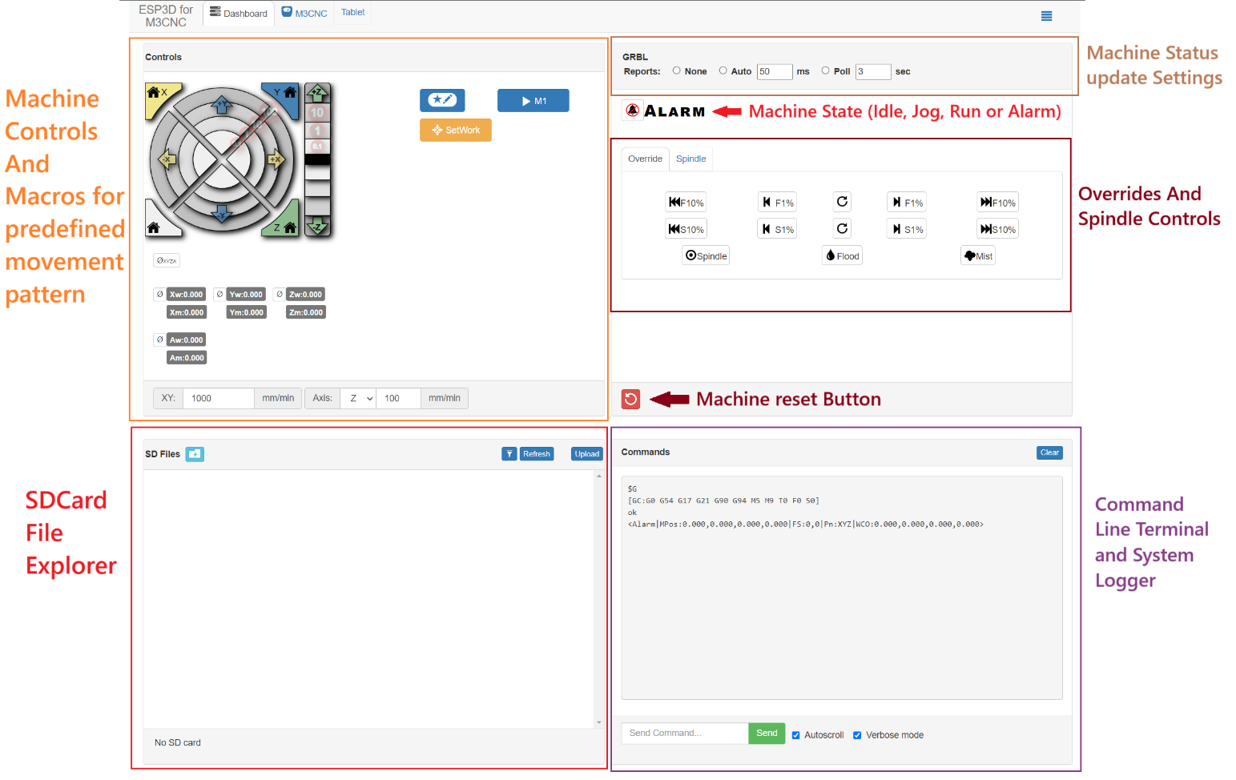

Figure Fluid NC UI Labeled diagram.

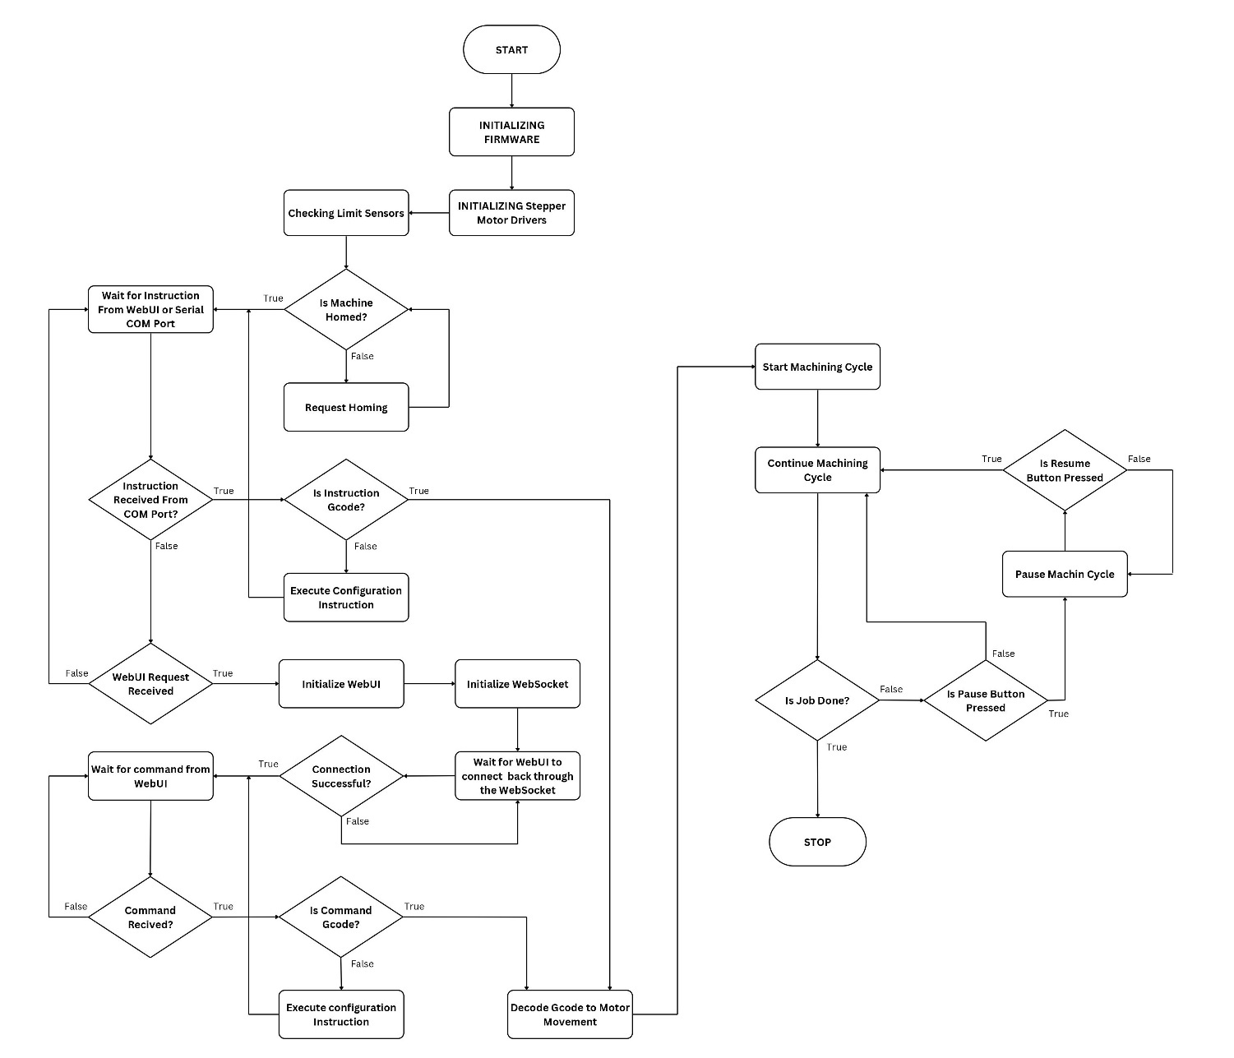

Figure Flow chart.

# 4 Experimental Setup

### Hardware Description

The product is a 4x4 ft sized CNC made from iron rods. Each axis has a different way of movement, the X axis will use Aluminium slides as a platform to move on and rack and pinion to instigate this movement. The Y axis will move on two or more iron rods which will also provide support for the Z axis.

A ball screw has been used for the Z axis to mount the router on it. Z axis consisting of a lead screw joined with a mount where the router can be placed. The 4th axis will be made using a 3-Jaw chuck and a static tail stock, this arrangement will allow us to grip and rotate the work piece of varying sizes.

### Components:

* + 1. Ball screw (z axis)

[13]The Ball Screw uses a recirculating ball mechanism between the screw shaft and the nut to convert rotary motion to linear motion with excellent efficiency. The ball screw is perfect for conserving drive motor power because it requires driving torque of no more than one-third that of a typical sliding screw. As shown in *figure no 17.* We are using the ball screw to perform linear actuation along z-axis.

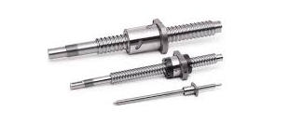

Figure Ball screw

* + 1. DMA 860H Stepper motor driver

A fully digital stepper drive built on the most recent advancements in motion control technology, the DMA860H uses a sophisticated DSP control

algorithm. A novel degree of system smoothness has been attained, offering maximum torque and eliminating mid-range instability. It allows for speedy setup to optimal settings with varying motors thanks to its motor auto-identification and parameter auto-configuration features. The DMA860H can drive a stepper motor with significantly less noise, heat, and jitter than conventional analog drives. DMA860H is a great option for applications with high requirements because of its distinctive features. An example is visible in *figure no 18.* We are using the Motor driver to supply our motor with the required power and select the direction and pulse of the motor.

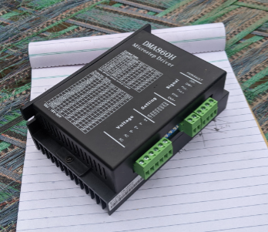

Figure Driver

* + 1. Nema 32 Stepper motor closed loop (x5)

NEMA is an acronym for the National Electrical Manufacturers Association which took it upon itself to start standardizing motor sizes using certain criteria. NEMA frame sizes include designations that can help you learn more about the size and capability of practically any motor. The stepper motor, shown in *figure 19*, is chosen because it allows us to count and calculate exact steps taken by the motor.

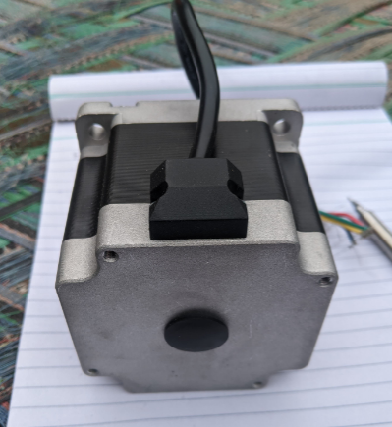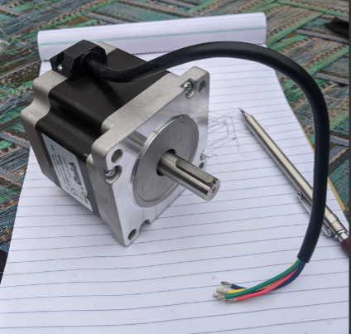

Figure Motors

* + 1. Inductive Proximity Sensors (x3)

[14]An inductive proximity sensor is a type of sensor that uses electromagnetic radiation instead of physical contact to identify metal targets. An inductive proximity sensor's sensing range varies according to the kind of metal it detects. The device is shown in *figure 20*. The proximity sensor is more than adequate for working on metallic objects because of its inductive probabilities.

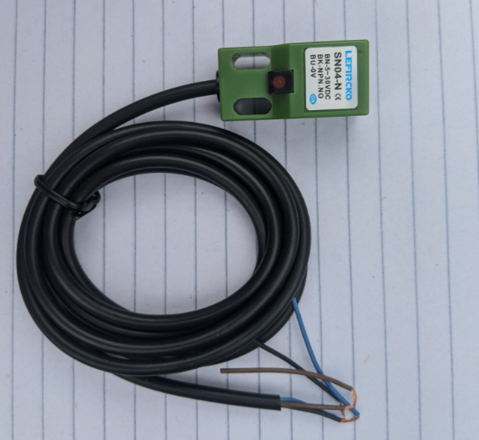

Figure Sensor

* + 1. Frame

The frame is built using iron rods as visible in *figure 21* the frame is made using swg road 16-gauge and 18-gauge. The 16-gauge rods are used for manufacturing the frame and the 18-gauge rods are utilised for construction for construction of the machine bed.

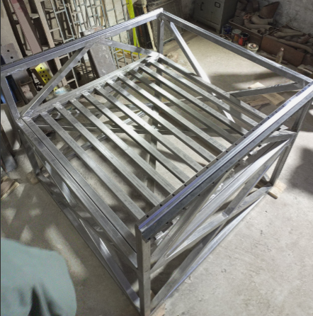

Figure Frame

* + 1. Y axis mounting

The y-axis is built using bended sheet metal. Two sheets of iron metal were welded together to form the square shape. As visible in *figure 22* there are two rails and a rack mounted on the beam.

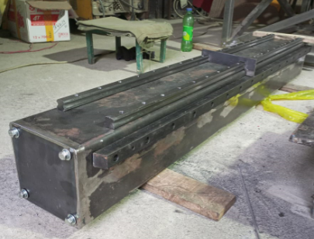

Figure Y axis

* + 1. Rack (x2)

A rack, like the ball screw, is used to perform linear actuation. As visible in *figure 23* there are sets of racks used, one for x-axis and the other for y-axis.

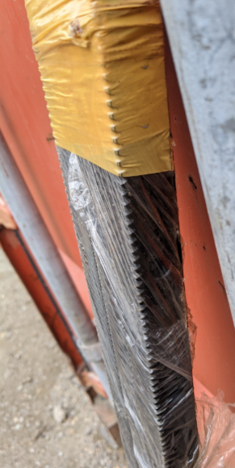

Figure Rack

* + 1. Aluminium rails with bearings

Aluinium rails provide a surface along which the ball bearings slide. The aluminium rails are used because they are light, cheap and easy to integrate with the assembly. The ball bearings have multiple small balls installed in them which move along the sides of the rails. These bearings have been chosen because they allow external lubrication for the balls over the time. As shown in *figure 23.*

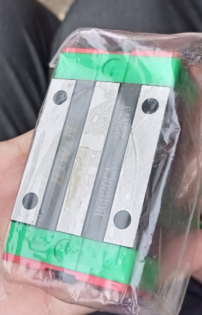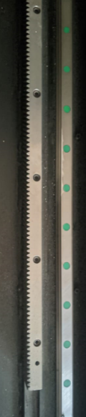

Figure Slide and bearings

* + 1. Wire Duct

The wire duct is used to provide protection and safety to wire clusters along the sides of the machine. As shown in *figure 24.*

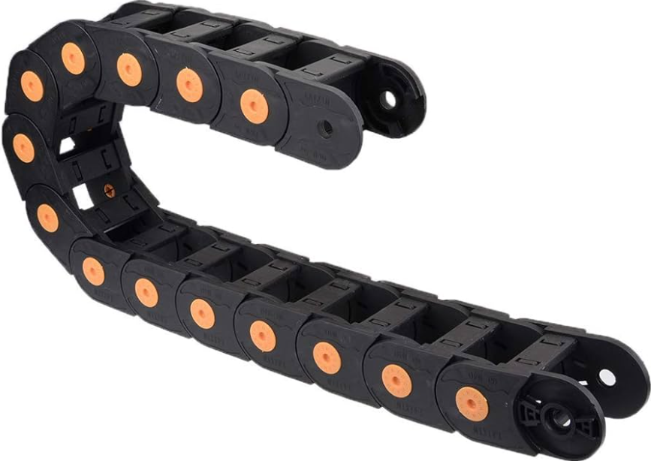

Figure Wire duct

* + 1. PCB

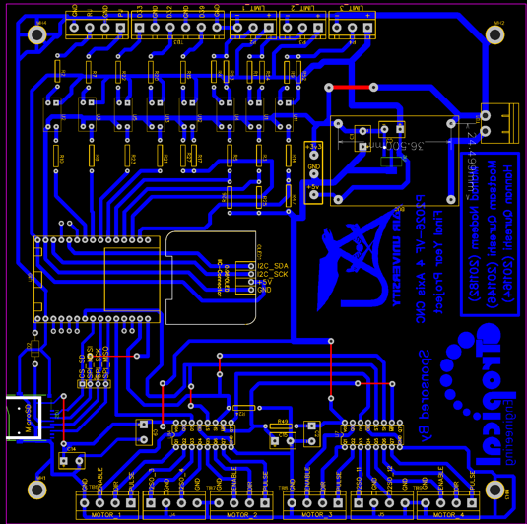

Figure PCB

* + 1. 3-jaw chuck

A three-jaw chuck is a multipurpose clamping tool that is frequently used in CNC milling, drill pressing, and metal, wood, or plastic turning operations on a lathe machine. They are mounted on the machine (lathe, CNC mill, etc.) by machine operators. As shown in *figure 25.*

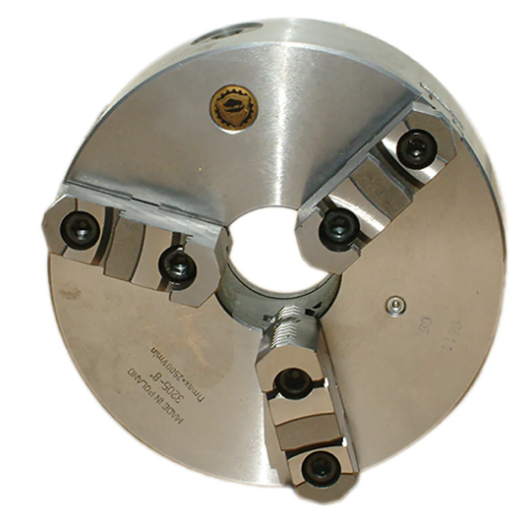

Figure chuck

* + 1. ESP 32

An Esp 32 is used, instead of an Arduino because of need of wireless connections which is a service that can be obtained by an Esp 32 shown in *figure 28*.

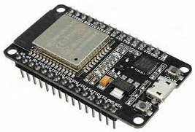

Figure Esp 32

* + 1. Static tailstock

[15]A tailstock, shown in *figure 29,* is intended to support the free end of a long work piece with a center during machine operations. It is frequently utilized as a component of a lathe or in conjunction with a rotary table on a milling machine.

The following are some benefits of utilizing a tailstock on a lathe machine: Support for long workpieces: During machining processes, the tailstock keeps long workpieces from bending or sagging by supporting their non-cutting end. This contributes to ensuring precision and accuracy in the result.

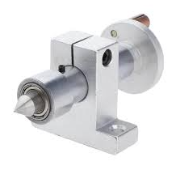

Figure Tail Stock

* + 1. LCD

The LCD is used to display the coordinates of each axis as well as the status of each proximity sensor.

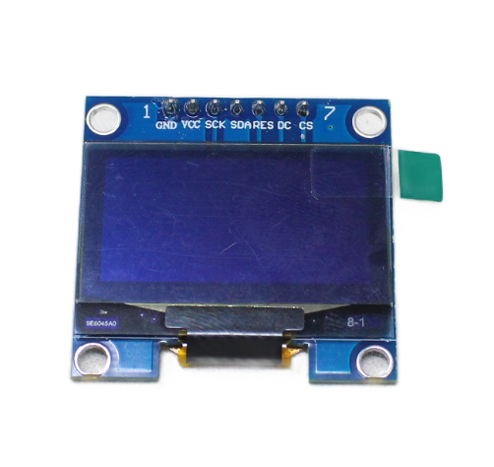

Figure LCD

* + 1. Capacitors

The capacitors are used to prevent circuitry issues.

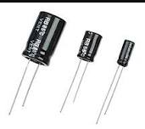

Figure Capacitors

* + 1. IC 74HC595

[16]A CMOS device with high speed is 74HC595 as shown in *figure 32*. On each positive shift of the shift register clock (SHCP), an eight-bit shift register receives data from the serial input (DS). The reset function () is independent of all clocks and, when asserted low, sets all shift register values to zero.

0 and is unaffected by any timepiece.

A rising pulse on the storage resister clock (STCP) transfers data from the input serial shift register to the output register. The 3-state outputs Q0-Q7 become active and present when the output enable (E asserted low) is set.

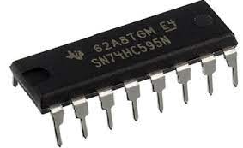

Figure IC

* + 1. Stoppers

Stoppers act as physical limit for the mechanism. As visible in *figure 33* the stoppers are mounted adjacent to the proximity sensors shown in *figure 20*.

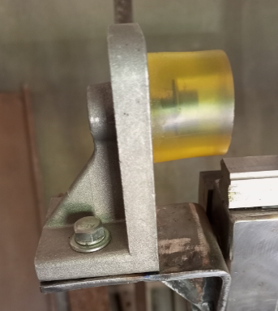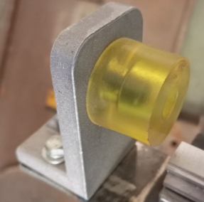

Figure stoppers

* + 1. Belts and gear

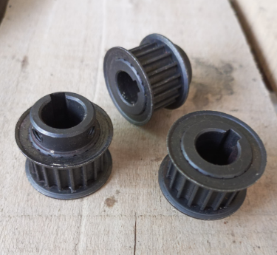

Figure Gear mount

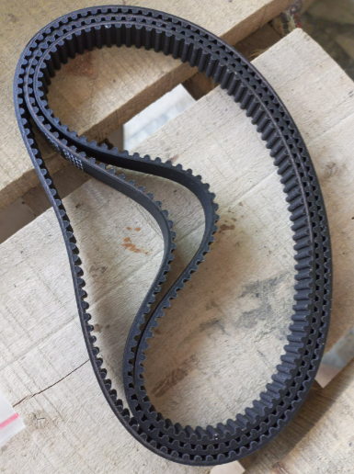

Figure Belt

* + 1. Gear Box

The gearbox set acts as a pinion coupled with the rack. The gearbox has a multi gear set where gear with smaller diameter is mounted on the rack and the one with the larger diameter is connected to the Stepper motor, shown in *figure 19*, with the help of Belts shown in *figure 35.*

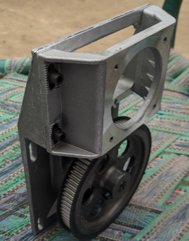

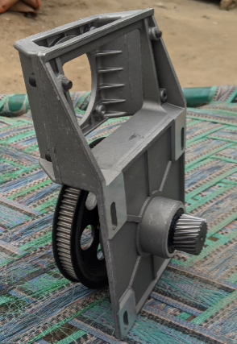

Figure Gear box (pinion)

* + 1. Resistors

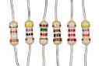

Figure Resistors

# 5 Results and Discussion

The activity initiated in the previous year will conclude in the upcoming month. The results and its details will be discussed in detail down below:

### Results

* 1. An open-source firmware called fluid NC has been used to run a code of multiple shapes and commands to operate at 3-axis minimum. While doing this task the achieved accuracy is up to 1mm which is more than adequate for operating on any wooden workpiece.

1. Moreover, the integration of an OLED display with the microcontroller which displays the status of the sensors as well as the displacement of the work tool with respect to its reference spot.
2. The frame (main body), including the detachable bed, of the product has been created using Iron rods as this material is easy to acquire and has enough strength and durability to prevent excessive vibrations and deformation caused due to excessive torque of the motors (if any).
3. The Y-axis is made using bent iron sheets welded together in a square shape. The y-axis has two rails with four bearing as well a single rack and pinion pair along with the gearbox. The y- axis supports the z-axis and assists the movement of the Router.
4. The x-axis is comprised of only a pair of slides, four bearings, two racks and pinions with two gearboxes. The bearings of the rails mounted on the frame are connected to the mountings on which the y-axis structure is rested on.
5. The Frame also houses four stoppers, one wire duct, and the control box which consists of the power supply and the PCB required for the product which includes the start stop buttons as well.

### Discussion

The main objective of this project was to create a local product which is cheap, reliable and stable in its working and maintenance.

The research conducted led to the conclusion that an average 3-axis CNC wood router machine costs around Rs. 1 million to Rs 1.2 million. The product manufactured

costs less than 30% of that price as the record mentioned below displays:

|  |  |  |
| --- | --- | --- |
| **No** | **Item name** | **Price (in Rs)** |
| **1** | **Iron Rods swg** | 34002 |
| **2** | **Proximity sensors (x3)** | 1350 |
| **3** | **Stoppers (x6)** | 5000 |
| **4** | **Nema 32 Stepper motors and drivers (x3)** | 70000 |
| **5** | **Bearings (x12)** | 19200 |
| **6** | **Rack (x3)** | 19500 |
| **7** | **Slides** | 25500 |
| **8** | **Gearbox + belt (x3)** | 19500 |
| **9** | **Wire duct (x2)** | 3600 |
| **10** | **Esp32** | 1000 |
| **11** | **Bolts & Nuts** | 7020 |
|  | **Total** | **205672** |

Table List of Expenditures

##### Project Impact

The impact of this project in the local market is sure to be astronomical as there is no such product available in the market even close to this price range.

1. The product increases the productivity of the local industry with the use of IIoT and the ability to work on 4-axis.
2. The product has given us the workers to travel and observe various local and imported products equally.
3. We have become more knowledgeable in the working of linear actuators.

### Project Outcome

The following are the goals that were addressed in the earlier sections of the reports:

1. The product is comparatively less expensive than any other product on the market.
2. The product can be used with an SD card, wifi, and cloud connectivity, indicating that the machine is an Internet of Things device.
3. The tool is simple to use and safe to use as it just needs to download or scan a net design. After the design has been converted into g-code, the machine will start.

# 6 Conclusions and Future Recommendations

### 6.1 Conclusions

The objectives stated in the former sections of the reports have been dealt with as:

1. The device has been successful in manufacturing a product which is relatively cheaper than any other product available on the market.
2. The product can run using wifi, SD card and cloud connection which displays that the machine runs using IoT.
3. The product is safe and easy to use as we can simply scan/download a design of the net. The machine will convert the design into a g-code which will then start the machine.

### 6.2 Future Recommendations

The goals have been partially achieved, to look forward to further enhancing and improving the product to best of the users understanding, following steps and improvements are proposed:

1. Convert the product to allow the user to machine materials other than wood in order to increase the usability and flexibility of the product.
2. Install the mechanism that allows the user to switch the machine between a 4-axis machine and a 3-axis machine depending on the requirements of the workpiece.
3. Make multiple products of similar specifications as such the user is able to operate a machine farm which will increase the productivity.
4. Install and integrate features in the machine’s algorithm which shall allow the machine to undertake the practice of predictive maintenance.

# Bibliography

|  |  |
| --- | --- |
| [1] | D. E. Kinza Yasar, "computer numerical control (CNC)," *What is computer numerical control (CNC)?,* p. 1, 2023. |
| [2] | Custom components, "4-axis CNC," *Benefits of 4-axis CNC,* vol. 1, p. 2, 2023. |
| [3] | Claire, "CNC routers," *What should you know about CNC routers,* 25 August 2023. |
| [4] | Trendmicro.com, "Industrial Internet of Things (IIoT)," *Definition of IIoT,* p. 2, may 06 2024. |
| [5] | United Nations, "SDG," *SDG Tracker: Measuring progress towards the Sustainable Development Goals,* vol. 1, no. 1, p. 1, july 18 2023. |
| [6] | T. G. b. 1. N. F. A. c. M. S. K. a. M. A. a. A. S. H. d. Md. Sazzadur Rahman a 1, "Industry 4.0," *Machine learning and internet of things in industry 4.0: A review,* vol. 28, p. 2, August 2023. |
| [7] | OLO 3d Printer and reviews, "Automatic CNC FX," *Next wave automtic CNC FX Pirhana ,* may 06 2024. |
| [8] | A. P. S. S. Sharma, "Design and review of CNC router," *A review of CNC routers,* 2024. |
| [9] | Y. Z. M. P. X. Zhang, "Analysis of CNC machine," *Global Sensitivity Analysis of a CNC machine tool,* vol. 81, no. 1-4, pp. 159-169, 2015. |
| [10] | M. J. a. P. J.I Mahmood, "CNC manipulators," *Design and development of a modular computer numerical control CNC machine manipulators for automation,* vol. 9, no. 1, pp. 58-66, Nov.2016. |
| [11] | R. Teja, "Introduction to ESP32," *Getting Started with ESP32 ,* p. 2, 2024. |
| [12] | Wiki, "Fluid NC," *Introduction to Fluid NC,* p. 2, Monday April 2024. |
| [13] | RBS 5, "Ball screw," *WHEN SHOULD YOU USE BALL SCREWS OVER LEAD SCREWS,* 25 January 2024. |
| [14] | M. Bludmir, "Proximity Sensors," *What are inductive proximity sensors?,* vol. 2, p. 2, 2023. |
| [15] | Wikipedia, "Tail stock," *Tails stock and its uses,* vol. 2, no. 3, p. 1, 22 april 2024. |
| [16] | Diodes Incorporated, "IC 74HC595," www.diodesncorporated.com, November 2018. |

# Appendix

1. **Set work g code:**

G90

G01 F4000 X449.012 Y438.693 Z0

G01 Z-226

1. **Triangle shape g code**

G90

G01 X0 Y0 Z0 F150

G01 Z-1

G01 Y30

G01 X30 Y15

G01 X0 Y0

G01 Z-1.2

G01 Y30

G01 X30 Y15

G01 X0 Y0

G01 Z-1.4

G01 Y30

G01 X30 Y15

G01 X0 Y0

G01 Z5

1. **Rectangle shape g code**

G90

G01 X0 Y0 Z0 F150

G01 Z-0.5

G01 Y40

G01 X20

G01 Y0

G01 X0

G01 Z-1

G01 Y40

G01 X20

G01 Y0

G01 X0

G01 Z-1.5

G01 Y40

G01 X20

G01 Y0

G01 X0

G01 Z5

1. **Circle Shape G Code**

G90

G01 X0 Y0 Z0 F150

G01 Z-0.5

G02 X0 Y0 I10 J0 F150

G01 Z-1

G02 X0 Y0 I10 J0 F150

G01 Z-1.5

G02 X0 Y0 I10 J0 F150

G00 Z5

# Turn it in Report



